1. Operational Definitions

The purpose of an operational definition is to express a hypothesis in explicit, objective, and measurable terms, which will be precisely the same for different individuals (scientists, clients, associates, etc.), permitting effective communication and replication of results.

or

To define a project goal in objective, measurable terms.

Involves (1) observable variable(s) and (2) measurement procedure.

Examples: mediating disputes about office temperature, commuting burden.

2. Quality Management

The quality paradox:
1. Quality increases profits
2. When profits decline, companies cut quality

Dimensions of Quality
- Quality of design refers to intentional differences between products or services that are designed by an engineer or planner.
- Quality of conformance refers to the degree to which a product or service conforms to, meets, and exceeds the standards set forth in the design specifications.
- Quality of performance refers to the long-term consistent functioning of the product and the related product characteristics of reliability, safety, serviceability, and maintainability.

Quality and Customers

Quality is defined by the individual needs, expectations, perceptions, and experience of the customer.

Customers include clients and associates.

Ongoing customer communication and feedback

Quality and Variability

The greater the variability, the lower the quality.
To control variability, continually monitor and statistically analyze data.

The Shewart-Deming Cycle: Plan, Do, Check, Act (PDCA)

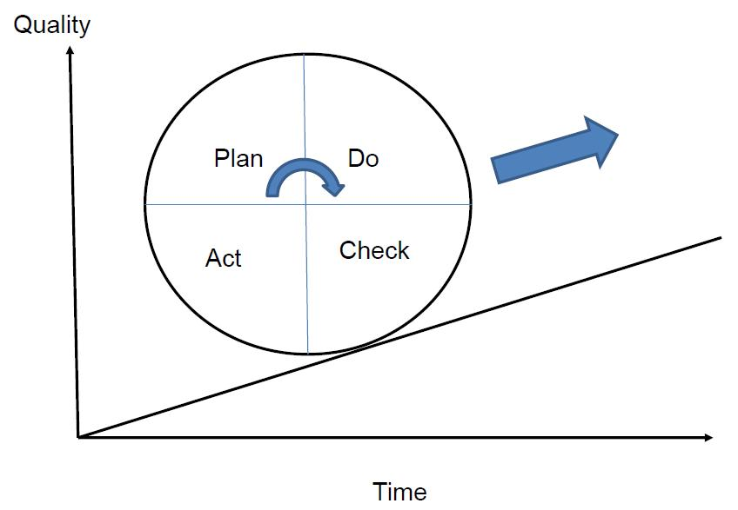

Plan:
– Define goals, customer needs
– Set product specifications
– Allocate resources (including human resources)
– Set timetable, define milestones, etc.

Do:
– Implement plan

Check:
– Monitor progress
– Evaluate quality on ongoing basis
– Control charts

Act:
– Corrective action

Video: The Plan, Do, Check, Act (PDCA) Cycle
http://www.youtube.com/watch?v=947wRN72Wg0

History of Quality Improvement

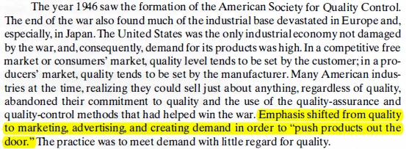

- Safety and Quality
- The Challenger Disaster (1986)
- Seven astronauts killed
- Shuttle program suspended for seven months
- Defective O-rings; organizational failures

- 'Six-Sigma' philosophy: http://en.wikipedia.org/wiki/Six_Sigma

Themes of Quality Improvement
- Primary focus is on continual Process Improvement.
- Most errors are due to the system, not individuals.
- Teamwork is an integral part of Quality Management.
- Customer satisfaction is a primary organizational goal.
- Organizational transformation is required for Quality Management.
"It is often the case that it takes a calamity to get organizations and people to change, but it is better to change before the calamity occurs."
- Fear must be removed from organizations. "Managers and workers are afraid of speaking out when something is wrong, asking for clarification, or admitting mistakes. These fears help perpetuate the current system and make it impossible for either the company or individual employees to improve.... Such fears prevent people from thinking and destroy intrinsic motivation. Often, what will happen in such an environment is that people will not initiate action."
- Quality costs less, not more; but requires investment in training.

Homework Read: pp. 16–17, 21–26 (§1.8, §1.10, §1.11)

Review: p. 27 (1.12 – 1.22; skip 1.17 & 1.21)

